**DIGITAL MARKETING ASSIGNMENT**

**NAME:** T. KAVIN AKASH

**NAAN MUDHALVAN ID**: DCE84FE672AAC69AB1D4FB5C38566637

1.Create a blog or website using Blogspot and WordPress. Customize the theme design and post new article with 500 words.

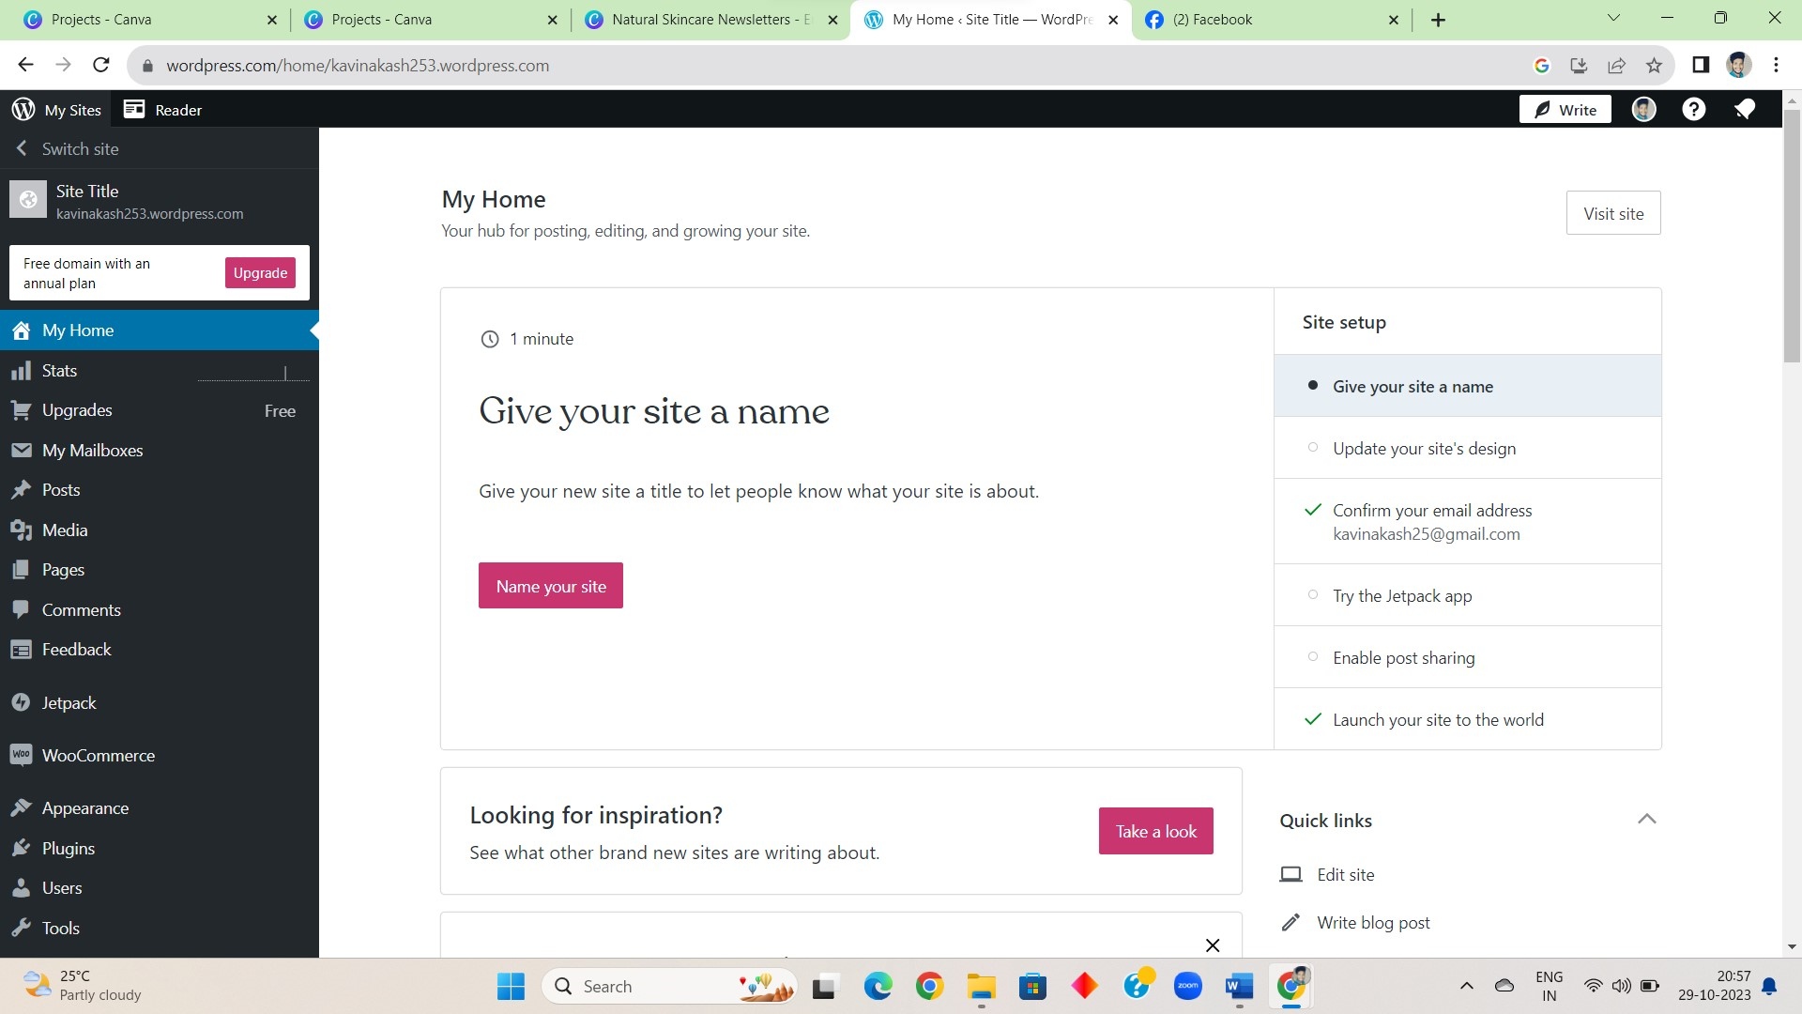

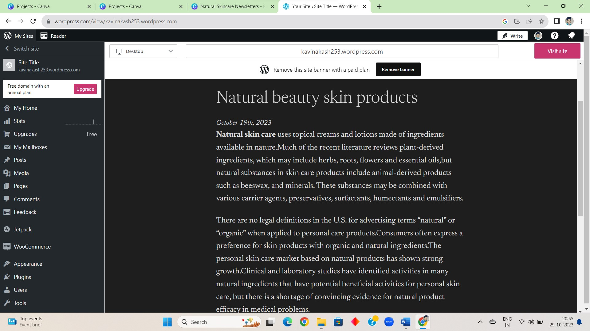

LINK:

<https://kavinakash253.wordpress.com/2023/10/19/hello-world/>

2. Create a New Facebook Business Page and post one social media poster for your brand.

SCREENSHOT:

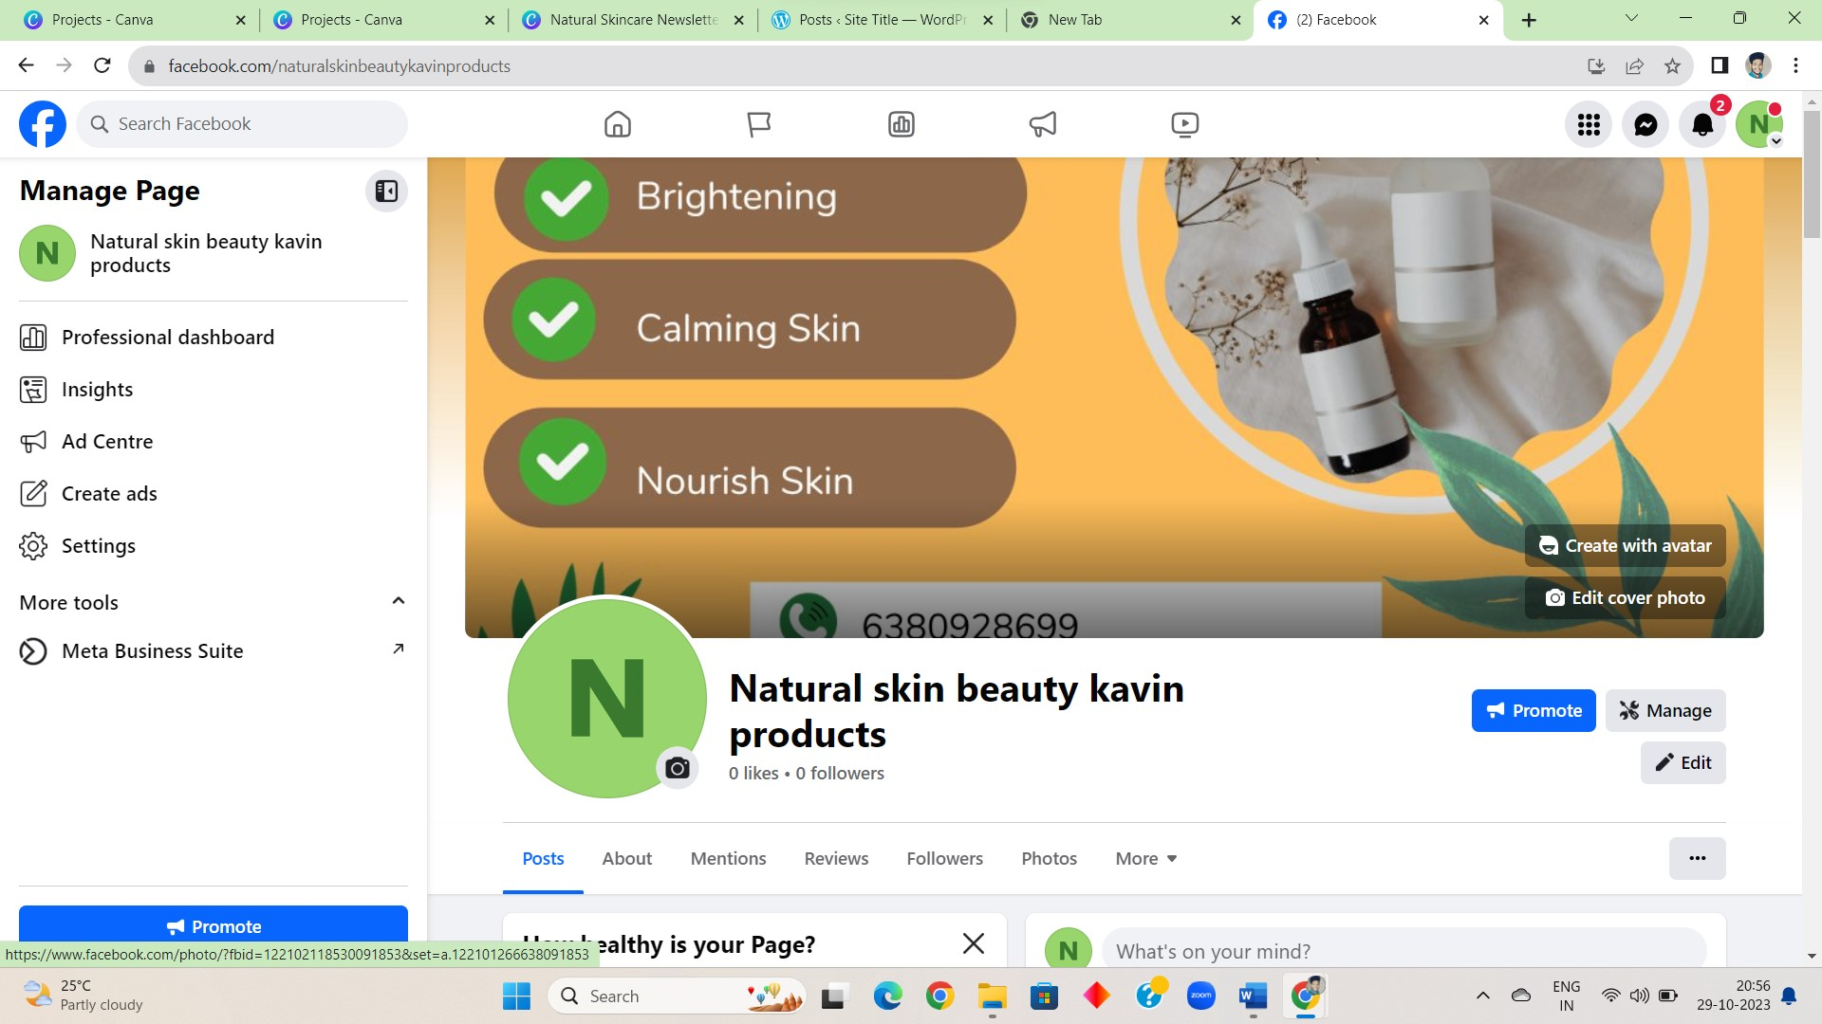

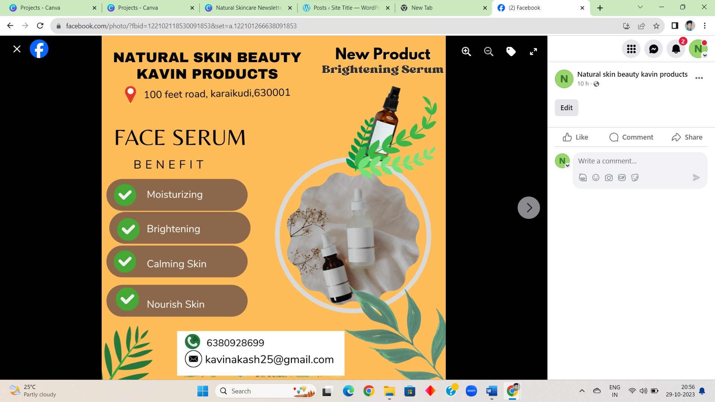

PROFILE LINK:

<https://www.facebook.com/naturalskinbeautykavinproducts>

POSTER LINK:

<https://www.facebook.com/naturalskinbeautykavinproducts/posts/1512441512906018:1512441512906018>

3. Create and design a social media advertisement poster using canva.

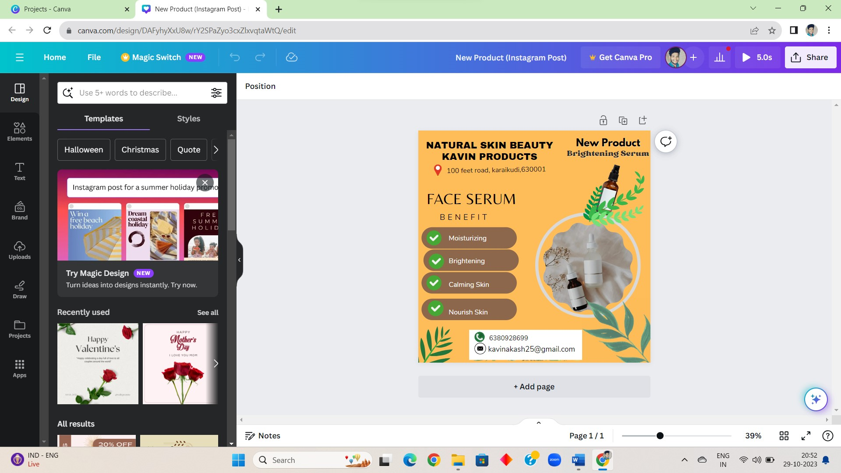

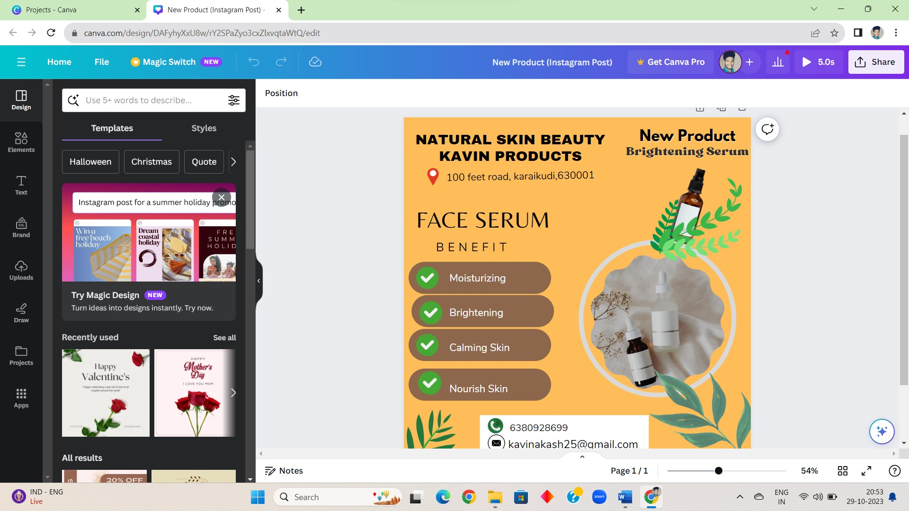

LINK:

<https://www.canva.com/design/DAFyhyXxU8w/Vg_qY4Ra0YrIV_7bHSMhTQ/watch?utm_content=DAFyhyXxU8w&utm_campaign=designshare&utm_medium=link&utm_source=editor>

4. Create email newsletter design using MailChimp or canva tool.

SCREENSHOT:

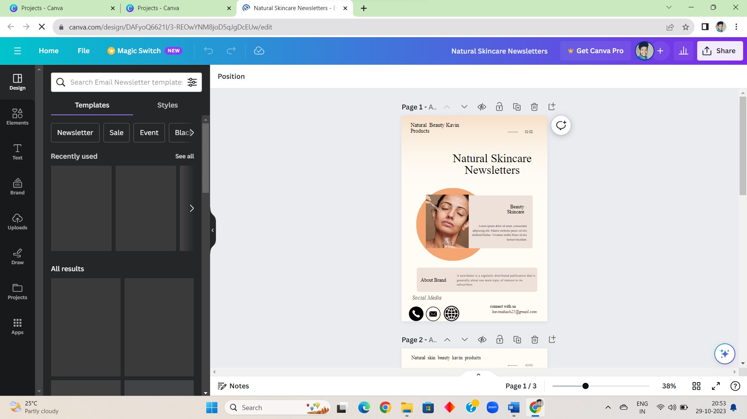

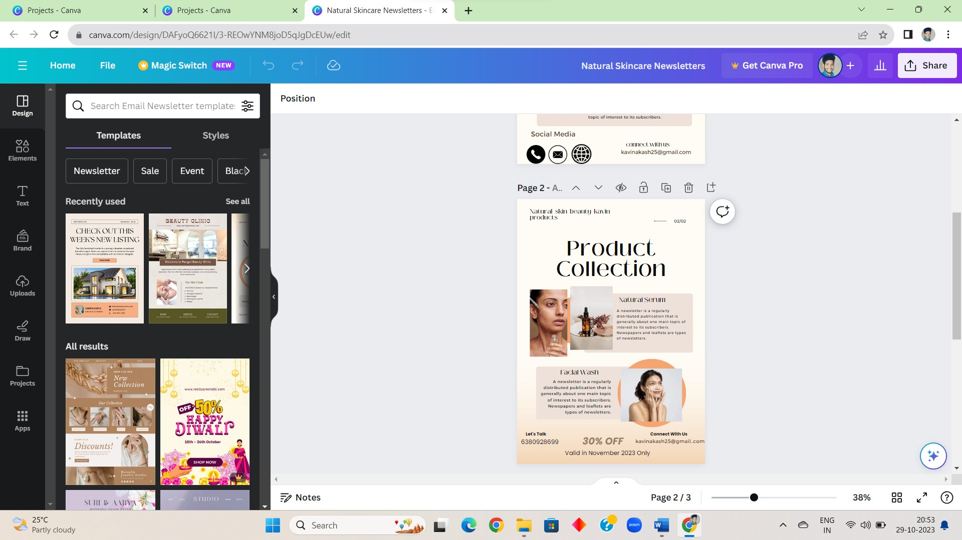

LINK:

<https://www.canva.com/design/DAFyoQ6621I/Qciqp11FPGgonxeJ-A0mtw/view?utm_content=DAFyoQ6621I&utm_campaign=designshare&utm_medium=link&utm_source=editor>